**ST.JOSEPH’S INSTITUTE OF TECHNOLOGY**

**DEPARTMENT OF COMPUTER SCIENCE AND ENGINEERING**

**INTEGRATION OF MACHINE LEARNING KAIROS APPROACH TO ANALYZE HUMAN PERSONALITY**

**A PROJECT REPORT**

By

ISWARIYA RAMU(312416104044)

GAYATHIRI.K(312416104037)

Under the guidance of

MR.C.GOWTHAM,M.E,

Assistant professor

Department of Computer Science and Engineering

St.Joseph’s Institute Of Technology

Chennai-600119

**ANNA UNIVERSITY: CHENNAI 600025**

**BONAFIDE CERTIFICATE**

Certified that this project report **“INTEGRATION OF DATA MINING CLUSTERING APPROACH TO ANALYZE HUMAN PERSONALITY**” is the bonafied work of **“ISWARIYA RAMU(312416104044)”and “GAYATHIRI.K (312416104037)”,**who carried out the project work under my supervision.

SIGNATURE SIGNATURE

**Dr. J. DAFNI ROSE** M.E, Ph.D, **MR.C.GOWTHAM,** M.E,

**Head of the Department, Assistant Professor,**

**Computer Science and Computer Science and**

**Engineering , Engineering,**

St.Joseph’s Institute of St. Joseph’s Institute of

Technology, Technology,

Old mamallapuram road, Old mamallapuram road,

Chennai - 600 119. Chennai - 600 119.

**ACKNOWLEDGEMENT**

We also take this opportunity to thank our honourable Chairman and Managing Director **Dr. B. BabuManoharan M.A., M.B.A., Ph.D.** for the guidance he offered during our tenure in this institution.

We extend our heartfelt gratitude to our honourable Director

**Mrs. B. Jessie Priya M.com.,** for providing us with the required resources to carry out this project.

We express our deep gratitude to our honourable CEO

**Mr.B. SashiSekarM.Sc(INTL.Business)** for the constant guidance and support for our project.

We are indebted to our Principal **Dr.P.RavichandranM.Tech., Ph.D.** for granting us permission to undertake this project.

Our earnest gratitude to our Head of the Department **Dr.J.DafniRose M.E.,Ph.D.** for her commendable support and encouragement for the completion of the project with perfection.

We express our profound gratitude to our guide **MR.C.GOWTHAM, M.E.**, for his guidance, constant encouragement, immense help and valuable advice for the completion of this project.

We wish to convey our sincere thanks to all the teaching and non-teaching staff of the department of **COMPUTER SCIENCE AND ENGINEERING** without whose co-operation this venture would not have been a success.

**CERTIFICATE OF EVALUATION**

College Name : St.JOSEPH’S INSTITUTE OF TECHNOLOGY

Branch : COMPUTER SCIENCE AND ENGINEERING

Semester : VII

|  |  |  |  |
| --- | --- | --- | --- |
| **Sl.No** | **Name of the Students** | **Title of the Project** | **Name of the Supervisor with designation** |
| **1**  **2** | **ISWARIYA RAMU(312416104044)**  **GAYATHIRI.K (312416104037)** | **INTEGRATION OF DATA MINING CLUSTERING APPROACH TO ANALYZE HUMAN PERSONALITY** | **MR.C.GOWTHAM,M.E**  **Assistant Professor ,**  **St.Joseph’s Institute of Technology** |

The reports of the project work submitted by the above students in partial fulfillment for the award of Bachelor of Engineering Degree in **Computer Science and Engineering** of Anna University were evaluated and confirmed to be reports of the work done by above students.

**(INTERNAL EXAMINER) (EXTERNAL EXAMINER)**

**TABLE OF CONTENTS**

**CHAPTER NO TITLE**

**ABSTRACT**

1. **INTRODUCTION** 
   1. OVERVIEW
   2. DOMAIN – DATA MINING
   3. RECOGNITION TESTS

1.3.1 PSYCOMETRIC TEST

1.3.2 IQ TEST

1.3.3 PEN TEST

* 1. PROBLEM DEFINITION

1. **LITERATURE SURVEY**
2. **SYSTEM DESIGN**
   1. EXISTING SYSTEM
   2. PROPOSED SYSTEM
3. **SYSTEM ARCHITECTURE** 
   1. ARCHITECTURE
4. **SYSTEM IMPLEMENTATION**

5.1 MODULE DESCRIPTION

5.1.1 FACIAL EXPRESSION RECOGNITION

5.1.2 SEMENTATION

5.1.3 FEATURE EXTRACTION

5.1.4 EYE EXTRACTION

5.1.5 EYEBROW EXTRACTION

5.1.6 MOUTH EXTRACTION

**ABSTRACT:**

The human face is an important part of an individual’s body and plays an important role in knowing the individual’s mood.The face is where a human expresses all his basic emotions.A facial expression is one or more motions or positions of the muscles beneath the skin of the face. According to one set of controversial theories, these movements convey the emotional state of an individual to observers. Facial expressions are a form of nonverbal communication. Humans can adopt a facial expression voluntarily or involuntarily, and the neural mechanisms responsible for controlling the expression differ in each case. Voluntary facial expressions are often socially conditioned and follow a cortical route in the brain. Conversely, involuntary facial expressions are believed to be innate and follow a subcortical route in the brain.In existing system, we examine the criminal mental disorders manually by assessing them but which has many disadvantages like we cannot predict any accurate solutions based on the assessment score because we might be not sure what kind of emotions the human user would be all time. To overcome this problem and suggest an effective solution for Criminal rehabilitation, we propose a hybrid architecture invoking facial based emotion sequence, PEN test, IQ test. By consistent monitoring of a human’s emotion and subjecting to PEN and IQ test, the human’s mental state is routed. Combination of above three techniques provides promising results for Criminal rehabilitation and self-control.

**CHAPTER -1**

**1.INTRODUCTION**

**1.1OVERVIEW**

Facial expressions can be considered not only as the most natural form of displaying human emotions but also as a key non-verbal communication technique. If efficient methods can be brought about to automatically recognize these facial expressions, striking improvements can be achieved in the area of human computer interaction. Research in facial emotion recognition has being carried out in hope of attaining these enhancements. In fact, there exist other applications which can benefit from automatic facial emotion recognition. Artificial Intelligence has long relied on the area of facial emotion recognition to gain intelligence on how to model human emotions convincingly in robots. Recent improvements in this area have encouraged the researchers to extend the applicability of facial emotion recognition to areas like chat room avatars and video conferencing avatars. The ability to recognize emotions can be valuable in face recognition applications as well. Suspect detection systems and intelligence improvement systems meant for children with brain development disorders are some other beneficiaries.

The processing of emotional facial expressions is modulated by personality; for example, neuroticism, a dimension of the five-factor model of personality has been found to play a role in this regard. Neuroticism is characterized by the tendency to be anxious, nervous, and hostile. Neuroticism is also considered to be a risk predictor for depression.

Cognitive and executive functions are often impaired in different clinical disorders, such as dementia, attention deﬁcit hyperactivity disorder, schizophrenia and obsessive compulsive disorder. In schizophrenia, cognitive impairments are often found in multiple areas, including visual information processing; attention; working memory; short-term memory and learning; executive functioning; speed of processing; reasoning and problem solving; context processing and social perception and cognition. The impairment of executive functions called “dysexecutive syndrome”, are common in neurological patients and are related to brain dysfunction speciﬁcally in the prefrontal cortex. Individuals who have an impairment of executive functions show problems of starting and stopping activities, a difﬁculty in mental and behavioral shifts, an increased distractibility and difﬁculties in learning new tasks. The executive functions, deﬁned as higher order cognitive functions needed for performing complex tasks, are often impaired also in patients with Obsessive Compulsive Disorder (OCD) which are characterized by the impairment of several skills such as attention, planning, problem-solving and behavioral control. Further, OCD is often associated with impairments of visuospatial skills, and of memory functioning, including visual, verbal, and numerical. Therefore, no single proﬁle of cognitive deﬁcits has been found to characterize all patients; the majority have impaired ability in at least one area of functioning and a standardized platform for assessing neurocognitive functioning is an important aspect of comprehensive treatment and research for this and other conditions.

**1.2 DOMAIN-MACHINE LEARNING AND DEEP LEARNING**

Deep Learning is nothing but a standard paradigm of Machine learning, or more precisely — one of its algorithms. For the greatest extent, it is based on a concept of a human brain and the interaction of neurons. After a series of articles by famous scientists, publications in scientific journals, the technology quickly became viral. Today, it has a variety of applications and yes significant place among them is occupied by face recognition. First of all, deep learning gives the power to build recognition biometric software that is capable of uniquely identifying or verifying a person. All this because deep learning methods are able to leverage very large datasets of faces and learn rich and compact representations of faces, allowing modern models to first perform as-well and later to outperform the face recognition capabilities of humans.

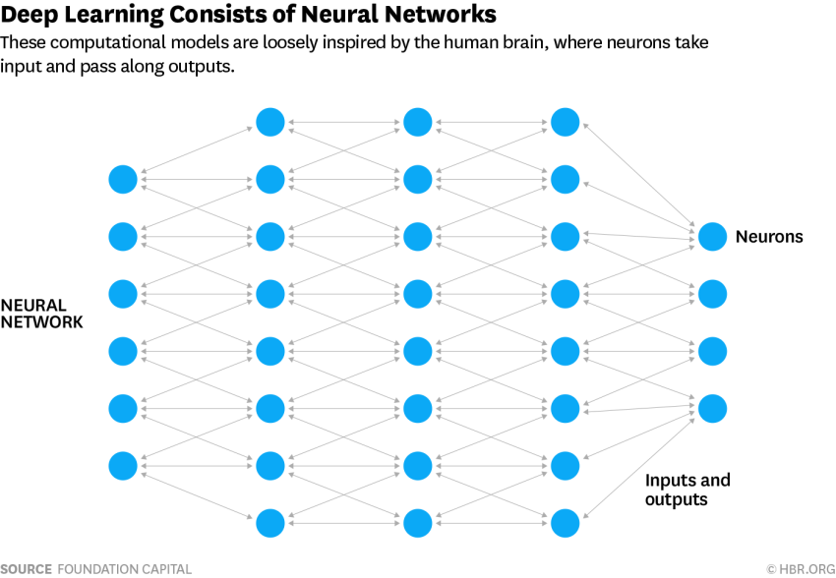

**1.3 RECOGNITION TESTS**

**1.3.1 PSYCOMETRIC TEST:**

The field is concerned with the objective measurement of skills and knowledge, abilities, attitudes, personality traits, and educational achievement. Some psychometric researchers focus on the construction and validation of assessment instruments such as questionnaires, tests, raters judgments, and personality tests. Others focus on research relating to measurement theory .

**1.3.2 IQ TEST:**

IQ scores are used for educational placement, assessment of intellectual disability, and evaluating job applicants. Even when students improve their scores on standardized tests, they do not always improve their cognitive abilities, such as memory, attention and speed. In research contexts they have been studied as predictors of job performance, and income.They are also used to study distributions of psychometric intelligence in populations and the correlations between it and other variables.

**1.3.3 PEN TEST:**

The process typically identifies the target systems and a particular goal, then reviews available information and undertakes various means to attain that goal. A penetration test target may be a white box (which provides background and system information) or black box (which provides only basic or no information except the company name). A gray box penetration test is a combination of the two (where limited knowledge of the target is shared with the auditor). A penetration test can help determine whether a system is vulnerable to attack if the defenses were sufficient, and which defenses (if any) the test defeated.

**1.4 PROBLEM DEFINITION**

Our objective is to improvise the effectiveness of precisely finding the changes in facial expression of humans, mainly focusing the criminal rehabilitation .We propose hybrid architecture invoking facial based emotion sequence using psychometric ,pen and IQ test.

CHAPTER-2

**2. LITERATURE SURVEY**

**TITLE**:

Polaris Koi, Susanne Uusitalo, Jarno Tuominen

Self-Control in Responsibility Enhancement and Criminal Rehabilitation, 2018

**DESCRIPTION:**

In this paper, we critically examine the promise of improving convicts’ capacity responsibility by neuro enhancements of self-control to see whether the special characteristics of the inmate population make a difference in the analyses. As improving self-control by means of neuro interventions seems plausible, we then ask whether it is or could be a justiﬁed measure in court rulings.

**TITLE**:

Shan Li ,Weihong Deng

Reliable crowdsourcing and deep locality –preserving learning for unconstrained facial expression recognition.

**DESCRIPTION:**

The purpose of the current study was to evaluate the executive functions by comparing the evaluations obtained using a neuropsychological battery with the one obtained using the virtual reality version of the Multiple Errands Test (V-MET). The study population included three groups: 10 patients affected by Obsessive Compulsive Disorder (OCD); 10 Schizophrenic patients; 10 healthy Controls. The results identiﬁed executive problems in clinical samples.

**CHAPTER-3**

**3. SYSTEM DESIGN**

* 1. **EXISTING METHOD**

Existing systems are highly complex in terms of time and storage for recognizing user behavior. Existing system focus on only manual assessment which takes time and doesn’t provide promising results as the user emotions keeps varying based on personal, situational problems. Existing system doesn’t invoke biometric based emotion recognition of the users. Existing system doesn’t focus on user facial expression with pyschometric test based automatic individual criminal behavior prediction.

**3.2 PROPOSED SYSTEM**

Mental Illness has a profound impact on people’s functioning, health and quality of life. Detecting early warnings of depression or any other mental illness is challenging. The proposed system provides a hybrid architecture invoking facial based emotion sequence, PEN test, IQ test. By consistent monitoring of a human’s emotion and subjecting to PEN and IQ test, the human’s mental state is routed. Combination of above three techniques provides promising results for Criminal rehabilitation and self-control. In our proposed system, the emotions are continuously monitored based on which the information for the classification of mental illness of the person is obtained. Further, using the information obtained, it conducts a psychology test to diagnose the severity of the mental condition. It combines these outputs with a psychometric study which consists of an IQ test and a Personality test.

**CHAPTER-4**

1. **SYSTEM ARCHITECTURE**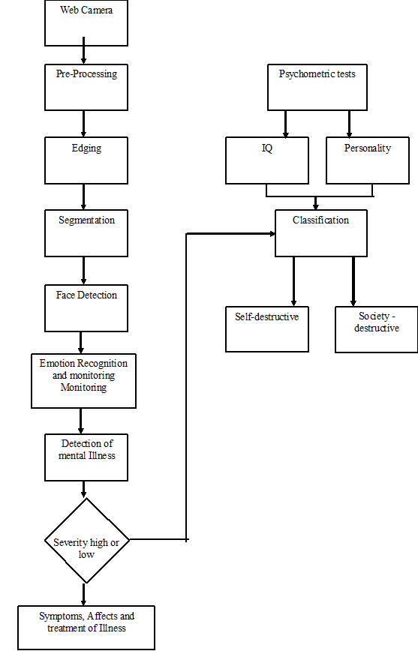

**CHAPTER-5**

**SYSTEM IMPLEMENTATION**

* 1. **MODULE DESCRIPTION**

**5.1.1** **Facial Expression Recognition:**

* The input image to the system can be captured using a web cam or can be acquired from the hard disk. This image undergoes image enhancement, where tone mapping is applied to images with low contrast to restore the original contrast of the image.
* Binarization : All RGB and gray scale images are converted into a binary image. This preprocessed image is fed into the face detection block.

**5.1.2 Segmentation:**

* A bounding box is formed over every feature of the face that contributes to an emotion.
* Each bounding box is derived using face coordinates
* These boxes are thus segmented and studied further to derive an emotion.

**5.1.3 Feature extraction:**

* The facial image obtained from the face detection stage forms an input to the feature extraction stage. To obtain real time performance and to reduce time complexity, for the intent of expression recognition, only eyes and mouth are considered. The combination of two features is adequate to convey emotions accurately.
* Finally, a corner *point detection algorithm* was used to obtain the required corner points from the feature regions.

**5.1.4 Eye Extraction**

* The eyes display strong vertical edges (horizontal transitions) due to its iris and eye white. Thus, the Sobel mask is applied to an image and the horizontal projection of vertical edges can be obtained to determine the Y coordinate of the eyes.

**5.1.5 Eyebrow Extraction**

* Two rectangular regions in the edge image which lies directly above each of the eye regions are selected as the eyebrow regions. The edge images of these two areas are obtained for further refinement. Now sobel method was used in obtaining the edge image since it can detect more edges than roberts method.
* These obtained edge images are then dilated and the holes are filled. The result edge images are used in refining the eyebrow regions.

**5.1.6 Mouth Extraction:**

* The top, bottom, right most and left most points of the mouth are been extracted and the centriod of the mouth is calculated.